CLASS – WORK

1. What is DDL :
Data Definition Language

2. DML;
Data Manipulation Language

3. State the Types of SQL categories
a. Data Manipulation Language
b. Data Control Language
c. Transaction Control Statement
d. Session Control Statement
e. Data Definition Language

4. Select keyword focus on what?
Table

5. From keyword focus on what?
Column

6. What is the port number for MySql?
Port – 3306

7. What is the port number for MySql server?
TCCP 1433

8. from catalog_sku_2018
display catalogid, sku, catalogpage and dateonwebsite
where the date is 01-JAN-2018
**Note** Cape_codd database(using both SSMS & Mysql)

ANS:

QUERY:

USE cape_codd;
Select CatalogID, SKU, Catalogpage, DateOnWebSite
from CATALOG_SKU_2018
where DateOnWebSite = '2018-01-01';

IMAGE

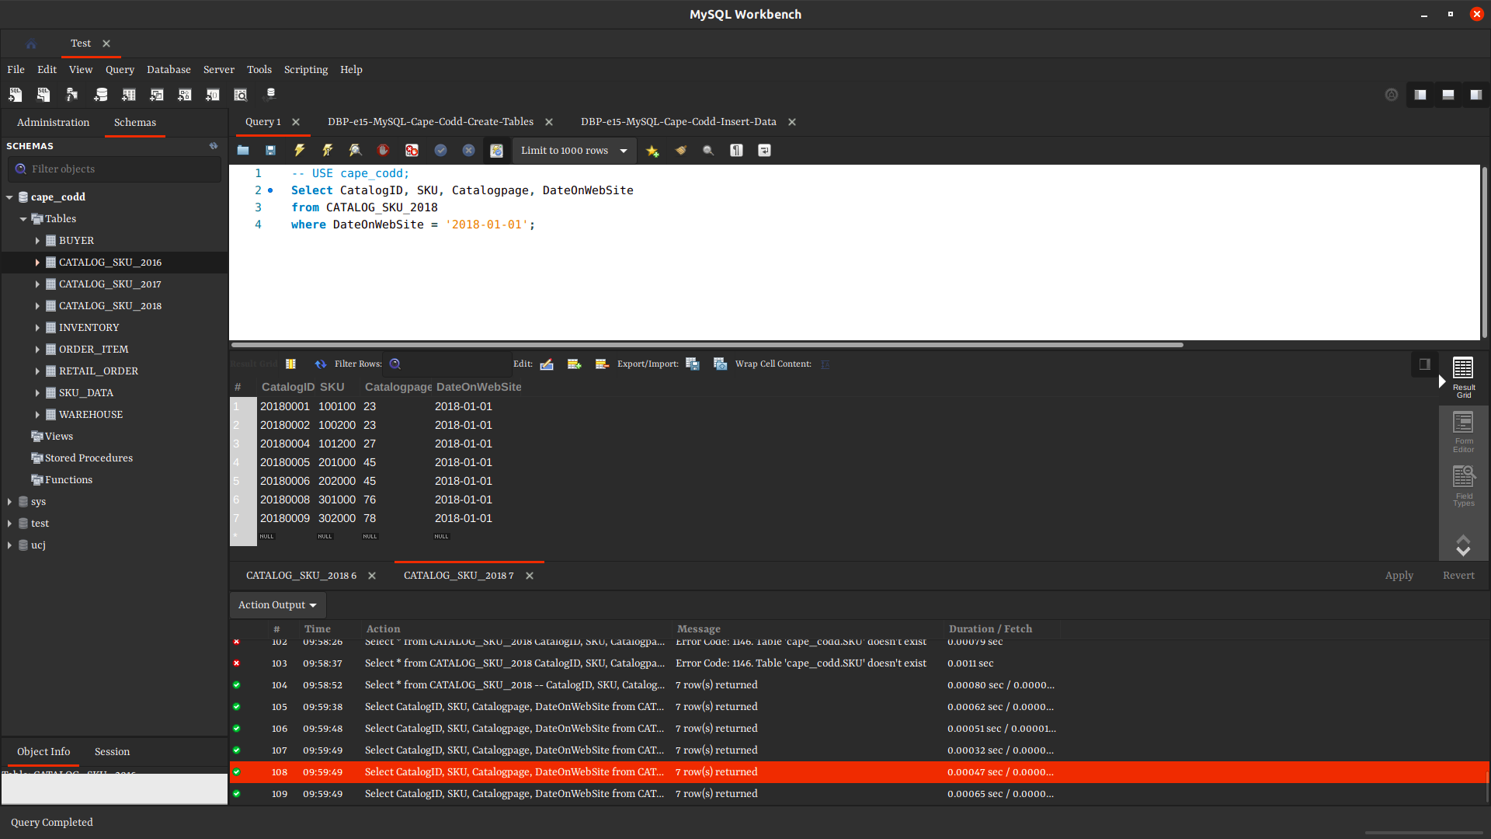

9. from sku_data table
display sku, buyer and department of camping alone
**Note** Cape_codd database

ANS:

QUERY:

-- USE cape_codd;

Select SKU, BUYER, DEPARTMENT
from SKU_DATA
where DEPARTMENT = 'Camping';

IMAGE:
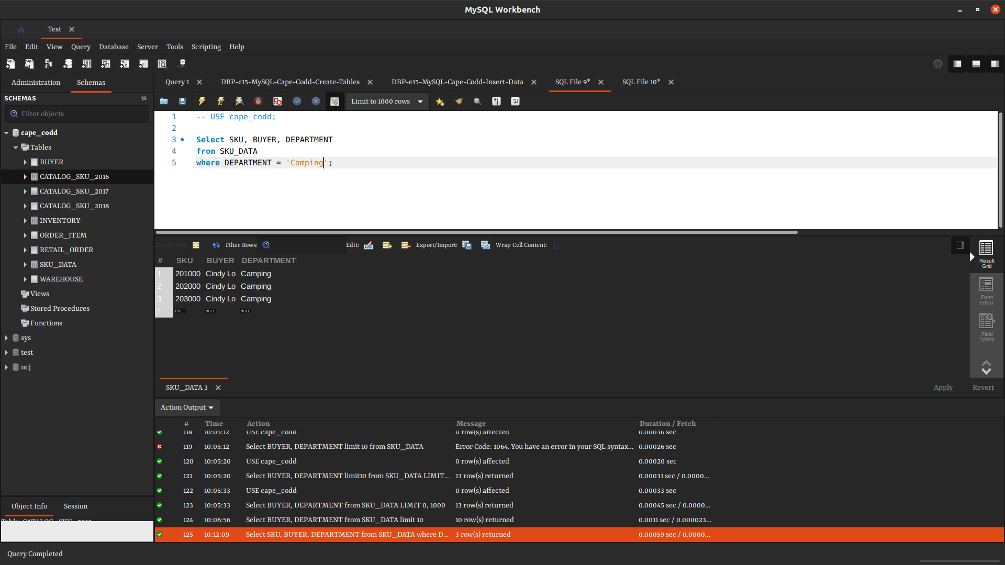

10. from Sku_data
Display the first 10 buyers alongside their department
**Note** Cape_codd database(using both SSMS & Mysql)

ANS:

QUERY:

-- USE cape_codd;

Select BUYER, DEPARTMENT
from SKU_DATA limit 10;

IMAGE:
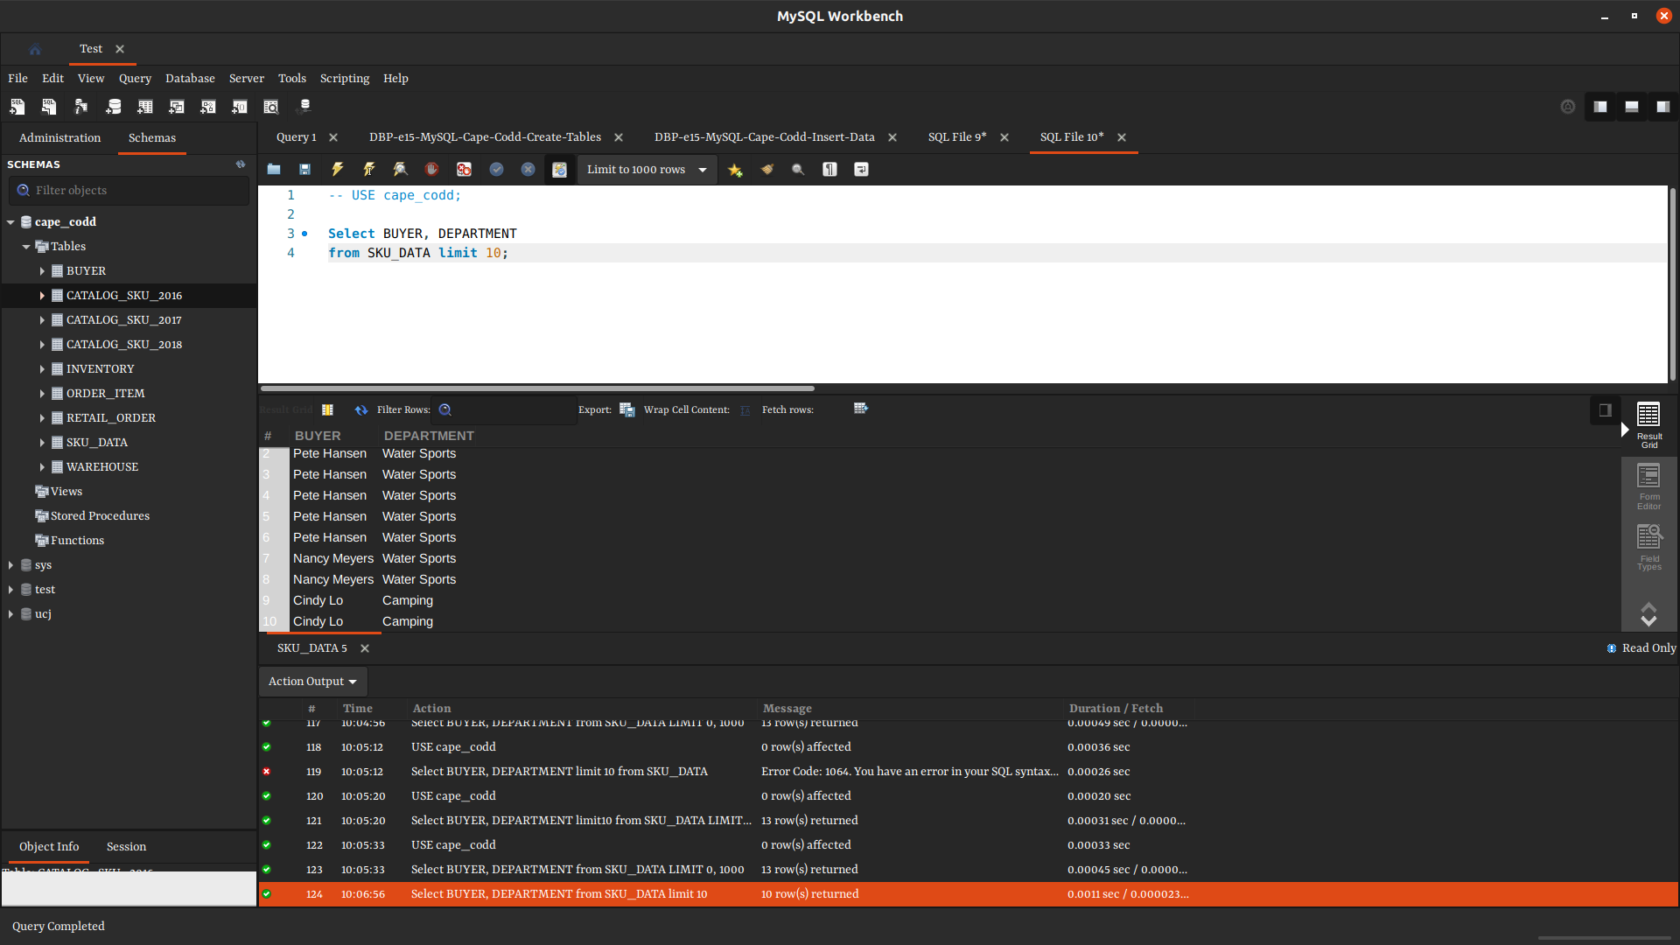

11. What is the statement for switch between database?
USE Sakila;

12. The use of Distinct in MySql query
Keyword ‘Distinct’ is used to remove duplicate values.

13. Five Sql comparison operators
= Equal to
>= Greater than equal to
<= Less than equal to
> Greater than
< Less than
<> Not Equal to

14. A table in RDBMS consist
Rolls and Column which are assigned to a (specific) datatype

15. Four examples of RDBMS database
a. MySQL
b. Oracle
c. IBM DB2
d. Microsoft SQL Server Database

16. In SQL query must the the column used in WHERE appear in SELECT line?
NO

17. Three types of logical operators in SQL and explain:
a. Arithmetic Operators: Arithmetic operators are used for mathematical operations on numerical data such as adding and subtracting.
b. Comparison Operators: these are operators used to compare two equal values and test whether they are the same
c. Compound Operators: these operators perform an operation on a variable and then set the result of the variable to the result of the operation.

18. Line with the error
MAX(ExtendedPrice) AS OrderItemMax,

19. What I understand by DATABASE:
DATABASE : can be defined as a structured set of data held in a computer, which are especially accessible in various ways.

19b. - Analyse data
- Predict data
- Prescribe data

20. Identify the error in the SQL query
1. SELECT Department, COUNT(*)

21.
AccountHolder | AccountType | DateOpened | AccountBalance
Cinemerem | Current Account | 01-01-2017 | 200,000

QUERY:
- - USE database;

SELECT AccountHolder, AccountType, DateOpened, AccountBalance
FROM Account
WHERE DateOpened = ‘10-01-2020’
AND AccountBalance > ₦100_000;

22. Limitation with aggregate function in SQL
a. Aggregate function can not be nested,
b. It can be used only in SELECT or HAVING clauses.

23. Types of database design process
a. Gathering requirements
Understanding what you want to do, and what you have is essential before you can dive into designing a database

b. Concept design
We specify the entities, columns, and their relationship. We may use an entity relationship (ER) diagram to visualize the database

c. Logic/Logical Design
It’s concerned about data model mapping; mapping a conceptual schema (like ER model) into logical schema to provide a much detailed description.

d. Physical design
It describes the details of how data is stored by defining tables, how the data is stored, define relationships in database management system.
This requires dealing with the DBMS, and could involve SQL.
24. List 4 functions of DBMS
a. protect data
b. compile data
c. control database
d. retrieve data

25. What are the component of a database component
- user
- database application
- database management system
- database access language

26. Display the number of times warehouseId appears in the inventory table for warehouseId with
rows more than 3 and where the quantity that was ordered is greater than 100.
**hint** output table should be 3 rows
keywords : group by, having

ANS:

QUERY:

